**Clear Reflection**

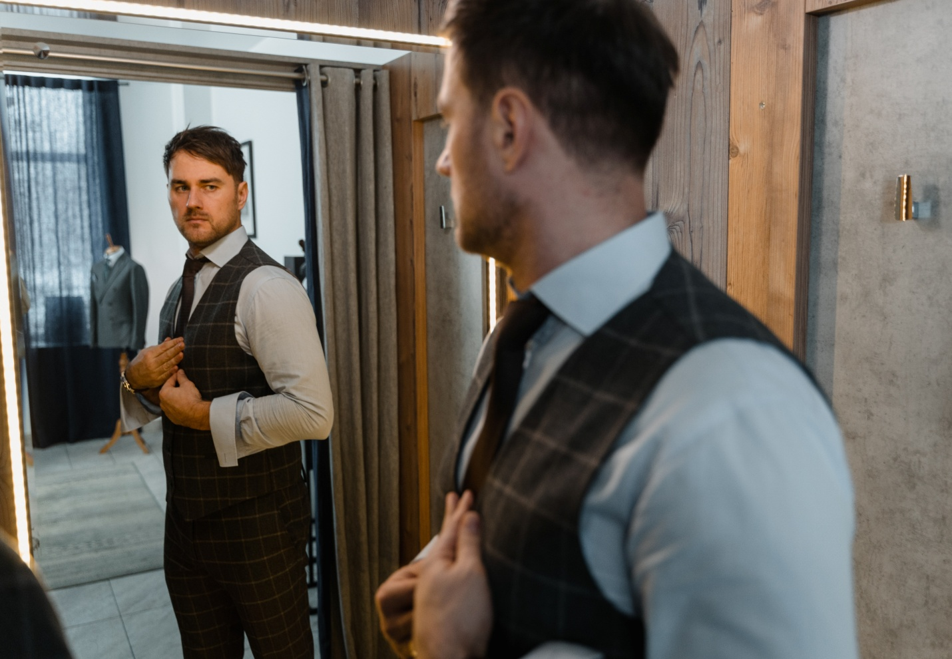

**Documentation**

***Students detail***

|  |  |
| --- | --- |
| **Student Name** | **Student ID** |
| Mohammad Mehsaan khan | Student1358307 |
| Ali Ahmed Butt | Student1360231 |
| Waseem Akram | Student1359545 |

**Faculty Details**

**Sir omair mushtaq**

**Cordinator**

**Miss wajeeha**

**Curriculam**

**7062**

**ACKNOWLEDGEMENT**

The first, we would like to express my special thanks of gratitude to my teacher Omair Mushtaq who helped us a lot in finalizing this project within the limited time frame, valuable counselling and assistance for the accomplishment of this project. Secondly, we would also like to thank the eProject team at Aptech Head Office, who gave us the golden opportunity to do this wonderful project about **Clear Reflection**.

Thirdly, we also thank the eProject team, some of the benefits are as under:

• Re-enforcement of skills happens in the experiential learning process.

• A mentor, ensuring that we do not get drifted, constantly guides us.

• It gives us a lot of confidence to face an interview as we have worked on a project. We can explain virtually everything on the subject we have learnt.

**SYNOPSIS**

Follow the strong development of the internet, technology watches and the growing watch market, every business needs a website design to display products on the internet.

Online Mirror shop is a web portal developed to display and sell home products online. It is fullfledged ecommerce site where customer can select product, add product to shopping cart and checkout. System administrator can add product, upload product image from web interface.

So, Clear Reflection shares the best product images through the website for everyone to know our products.

However, purchases are not made directly on the website, we are working on it.

**PROBLEM DEFINITION**

Clear Reflection is very big shop of mirror in the city. With the success of the shop, owner had opened few more shops in the different cities also. Our product is known for their quality of the service which they are providing since 1985. In order to advertise about the company and also to start online services the company wishes to make the website of the company.

**CUSTOMER**

**REQUIREMENT**

**SPECIFICATION**

**(CRS)**

The Web site is to be created based on the following requirements.

1) The Home Page should be created making with proper sections and with a suitable logo.

2) The look and feel of the project must be made user friendly and uniformity in the color combination must be maintained.

3) About us, Contact Us (address and map) must be added. In the Contact Us page the website of all the shops location must be given.

4) All the categories of the products like bedroom , bathroom, wooden, Bluetooth, LED. UPCOMING PRODUCTS & so on. For each product the cost must be mentioned in the list

5) Contact Us, About Us.

6) Gallery section can be included.

7) Navigation of the project must be made user friendly.

8) Customer must be allowed to place the order by selecting the product.

9) While placing the dummy order, the total cost of the order must be calculated.

**SCOPE OF THE**

**WORK (IN BRIEF)**

The website is to be developed for the Windows Platform using HTML5, CSS, Bootstrap, jQuery and JavaScript and. The site should work well in all leading browsers including Chrome, IE, Firefox, Opera and Microsoft Edge etc.

**Homepage show:**

1.Logo

2.Navbar

3.Image Slider

4.Upcoming Products

5.Products images

6.Reviews

7.Info

8.Footer

**About Us page show:**

1.Logo

2.Navbar

3.Video

4.Info

5.Footer

**Contact Us page show:**

1.Navbar

2.Contact Us

3.Map

4.Footer

**Product Pages Contain:**

1.Navbar

2.Product Details

3.Product Card

4.Add to cart

Metal.html

Garden.html

Electric.html

Draw.html

Draw.html

Led.html

acrylic.html

Bluetooth.html

Wooden.html

Bathroom.html

Bedrooom.html

Bedroom mirror

Bathroom mirror

Bluetooth mirror

Wooden mirror

LED

Drawing mirror

Acrylic mirror

Electric mirror

Dressing mirror

Garden mirror

Metal mirror

About.html

Contact us.html

Home.html

About page

Product page

Contact us page

Home page

• Home page (home.html)

• About Page (about.html)

• Contact-Us page (contact.html)

• Product (product.html)

1. Bedroom mirror (bedroom.html)

2. Bathroom mirror (bathroom.html)

3. Wooden mirror (wooden.html)

4. Bluetooth mirror (bluetooth.html)

5. LED (led.html)

6. Acrylic mirror (acrylic.html)

7. Drawing mirror (draw.html)

8. Dressing mirror (dress.html)

9. Electric mirror (electric.html)

10. Garden mirror (garden.html)

11. Metal mirror (metal.html)

• Cart (cart.html)

**Task Sheet Review:**

|  |  |  |  |  |
| --- | --- | --- | --- | --- |
| **S.no** | **Tasks** | **Date** | Group members | **Status** |
| **1** | Analysis | **12/6/22** | Mohammad mehsaan,  ALI BUTT,  WASEEM AKRAM | Complete |
| **2** | Wireframes | **14/6/22** | Mohammad mehsaan,  ALI BUTT,  WASEEM AKRAM | Complete |
| **3** | Data  Collections | **16/6/22** | Mohammad mehsaan,  ALI BUTT,  WASEEM AKRAM | Complete |
| **4** | Home Page | **18/6/22** | Mohammad mehsaan,  ALI BUTT,  WASEEM AKRAM | Complete |
| **5** | Product Pages | **20/6/22** | Mohammad mehsaan,  ALI BUTT,  WASEEM AKRAM | Complete |
| **6** | Gallery Page | **22/6/22** | Mohammad mehsaan,  ALI BUTT,  WASEEM AKRAM | Complete |
| **7** | Compile all  Pages | **24/6/22** | Mohammad mehsaan,  ALI BUTT,  WASEEM AKRAM | Complete |
| **8** | Responsiveness | **26/6/22** | Mohammad mehsaan,  ALI BUTT,  WASEEM AKRAM | Complete |
| **9** | JavaScript | **28/6/22** | Mohammad mehsaan,  ALI BUTT,  WASEEM AKRAM | Complete |
| **10** | Validations | **30/6/22** | Mohammad mehsaan,  ALI BUTT,  WASEEM AKRAM | Complete |
| **11** | Finalization | **2/7/22** | Mohammad mehsaan,  ALI BUTT,  WASEEM AKRAM | Complete |
| **12** | Documentation | **5/7/22** | Mohammad mehsaan,  ALI BUTT,  WASEEM AKRAM | Complete |